Chapter 12
Estimating the Cost of Capital
12-1. Suppose Pepsico’s stock has a beta of 0.57. If the risk-free rate is 3% and the expected return of the market portfolio is 8%, what is Pepsico’s equity cost of capital?
3% + 0.57 × (8% – 3%) = 5.85%
12-2. Suppose the market portfolio has an expected return of 10% and a volatility of 20%, while Microsoft’s stock has a volatility of 30%.
a. Given its higher volatility, should we expect Microsoft to have an equity cost of capital that is higher than 10%?
b. What would have to be true for Microsoft’s equity cost of capital to be equal to 10%?
a. No, volatility includes diversifiable risk, so it cannot be used to assess the equity cost of capital.
b. Microsoft stock would need to have a beta of 1.
12-3. Aluminum maker Alcoa has a beta of about 2.0, whereas Hormel Foods has a beta of 0.45. If the expected excess return of the marker portfolio is 5%, which of these firms has a higher equity cost of capital, and how much higher is it?
Alcoa is 5% × (2 – 0.45) = 7.75% higher.
12-4. Suppose all possible investment opportunities in the world are limited to the five stocks listed in the table below. What does the market portfolio consist of (what are the portfolio weights)?
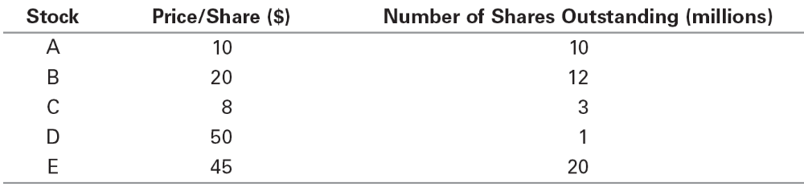

Total value of the market 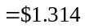 billion
Stock | Portfolio Weight
A | 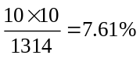
B | 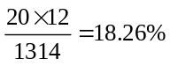
C | 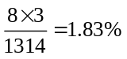
D | 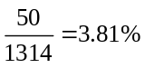
E | 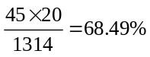
12-5. Using the data in Problem 4, suppose you are holding a market portfolio, and have invested $12,000 in Stock C.
a. How much have you invested in Stock A?
b. How many shares of Stock B do you hold?
c. If the price of Stock C suddenly drops to $4 per share, what trades would you need to make to maintain a market portfolio?
a. 12,000 × (MC A / MC C) = 12,000 × (10 × 10)/(8 × 3) = $50,000
b. 12,000/8 = 1,500 shares of B,
1,500 × (shares B/shares C) = 1,500 × 12/3 = 6,000 shares of B
c. No trades are needed; it is a passive portfolio.
12-6. Suppose Best Buy stock is trading for $20 per share for a total market cap of $6 billion, and Walt Disney has 1.8 billion shares outstanding. If you hold the market portfolio, and as part of it hold 100 shares of Best Buy, how many shares of Walt Disney do you hold?
Best Buy has 6/20 = 0.3 billion shares outstanding.
Therefore, you hold 100 × (1.8/0.3) = 600 shares of Disney.
12-7. Standard and Poor’s also publishes the S&P Equal Weight Index, which is an equally weighted version of the S&P 500.
a. To maintain a portfolio that tracks this index, what trades would need to be made in response to daily price changes?
b. Is this index suitable as a market proxy?
a. Sell winners and buy losers to maintain an equal investment in each.
b. No. The market portfolio should represent the aggregate portfolio of all investors. However, in aggregate, investors must hold more of the larger market cap stocks; the aggregate portfolio is value weighted, not equally weighted.
12-8. Suppose that in place of the S&P 500, you wanted to use a broader market portfolio of all U.S. stocks and bonds as the market proxy. Could you use the same estimate for the market risk premium when applying the CAPM? If not, how would you estimate the correct risk premium to use?
No, expected return of this portfolio would be lower due to bonds. Compute the historical excess return of this new index.
12-9. From the start of 1999 to the start of 2009, the S&P 500 had a negative return. Does this mean the market risk premium we should have used in the CAPM was negative?
No! Investors were not expecting a negative return. To estimate an expected return, we need much more data.
12-10. You need to estimate the equity cost of capital for XYZ Corp. You have the following data available regarding past returns:
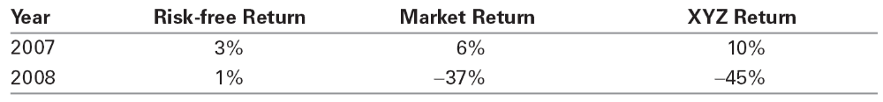
a. What was XYZ’s average historical return?
b. Compute the market’s and XYZ’s excess returns for each year. Estimate XYZ’s beta.
c. Estimate XYZ’s historical alpha.
d. Suppose the current risk-free rate is 3%, and you expect the market’s return to be 8%. Use the CAPM to estimate an expected return for XYZ Corp.’s stock.
e. Would you base your estimate of XYZ’s equity cost of capital on your answer in part (a) or in part (d)? How does your answer to part (c) affect your estimate? Explain.
a. (10% – 45%)/2 = –17.5%
b. Excess returns:
MKT 3%, –38%
XYZ 7%, –46%
Beta = (7 – (–46))/(3 – (–38)) = 1.29
c. Alpha = intercept =
E[R_{s} – r_{f}] – beta × (E[R_{m} – r_{f}]) =
(7% – 46%)/2 – 1.29 × (3% – 38%)/2 = 3.1%
d. E[R] = 3% + 1.29 × (8% – 3%) = 9.45%
e. Use (d)—CAPM is more reliable than average past returns, which would imply a negative cost of capital in this case!
Ignore (c), as alpha is not persistent.
12-11. Go to Chapter Resources on MyFinanceLab and use the data in the spreadsheet provided to estimate the beta of Nike and Dell stock based on their monthly returns from 2007–2011. (Hint: You can use the slope() function in Excel.)
NKE 0.90
Dell 1.36
12-12. Using the same data as in Problem 11, estimate the alpha of Nike and Dell stock, expressed as % per month. (Hint: You can use the intercept() function in Excel.)
NKE = 1.4%/month
Dell = –0.4% per month
12-13. Using the same data as in Problem 11, estimate the 95% confidence interval for the alpha and beta of Nike and Dell stock using Excel’s regression tool (from the data analysis menu) or the linest() function.
 | Coefficients | Standard Error | t Stat | P-value | Lower 95% | Upper 95%
Intercept | –0.004095 | 0.010395 | –0.393979 | 0.695043 | –0.024903 | 0.016712
Slope | 1.361232 | 0.191852 | 7.095196 | 2.03E–09 | 0.977197 | 1.745265

 | Coefficients | Standard Error | t Stat | P-value | Lower 95% | Upper 95%
Intercept | 0.013844 | 0.007108 | 1.947763 | 0.056289 | -0.00434 | 0.021528
Slope | 0.899096 | 0.131184 | 6.853724 | 5.16E–09 | 0.636504 | 1.161689
12-14. In mid-2012, Ralston Purina had AA-rated, 10-year bonds outstanding with a yield to maturity of 2.05%.
a. What is the highest expected return these bonds could have?
b. At the time, similar maturity Treasuries have a yield of 1.5%. Could these bonds actually have an expected return equal to your answer in part (a)?
c. If you believe Ralston Purina’s bonds have 1% chance of default per year, and that expected loss rate in the event of default is 40%, what is your estimate of the expected return for these bonds?
a. Risk-free => y = 2.05%
b. no
c. y – d × l = 2.05% – 1%(.40) = 1.65%
12-15. In mid-2009, Rite Aid had CCC-rated, 6-year bonds outstanding with a yield to maturity of 17.3%. At the time, similar maturity Treasuries had a yield of 3%. Suppose the market risk premium is 5% and you believe Rite Aid’s bonds have a beta of 0.31. The expected loss rate of these bonds in the event of default is 60%.
- What annual probability of default would be consistent with the yield to maturity of these bonds in mid-2009?
- In mid-2012, Rite-Aid’s bonds had a yield of 8.3%, while similar maturity Treasuries had a yield of 1%. What probability of default would you estimate now?
a. Rd = 3% + 0.31(5%) = 4.55% = y – pL = 17.3% – p(0.60)
p = (17.3% – 4.55%)/0.60 = 21.25%
b. p = (8.3% – 1% – 0.31(5%))/0.60 = 9.6%
12-16. During the recession in mid-2009, homebuilder KB Home had outstanding 6-year bonds with a yield to maturity of 8.5% and a BB rating. If corresponding risk-free rates were 3%, and the market risk premium was 5%, estimate the expected return of KB Home’s debt using two different methods. How do your results compare?
Given the low rating of debt, as well as the recessionary economic conditions at the time, we know the yield to maturity of KB Home’s debt is likely to significantly overstate its expected return. Using the recession estimates in Table 12.2 and an expected loss rate of 60%, from Eq. 12.7 we have
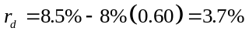
Alternatively, we can estimate the bond’s expected return using the CAPM and an estimated beta of 0.17 from Table 12.3. In that case,
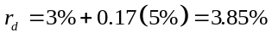
While both estimates are rough approximations, they both confirm that the expected return of KB Home’s debt is well below its promised yield.
12-17. The Dunley Corp. plans to issue 5-year bonds. It believes the bonds will have a BBB rating. Suppose AAA bonds with the same maturity have a 4% yield. Assume the market risk premium is 5% and use the data in Table 12.2 and Table 12.3.
a. Estimate the yield Dunley will have to pay, assuming an expected 60% loss rate in the event of default during average economic times. What spread over AAA bonds will it have to pay?
b. Estimate the yield Dunley would have to pay if it were a recession, assuming the expected loss rate is 80% at that time, but the beta of debt and market risk premium are the same as in average economic times. What is Dunley’s spread over AAA now?
c. In fact, one might expect risk premia and betas to increase in recessions. Redo part (b) assuming that the market risk premium and the beta of debt both increase by 20%; that is, they equal 1.2 times their value in recessions.
a. Use CAPM to estimate expected return, using AAA rate as rf rate: r + 0.1 × rp = 4% + 0.10(5%) = 4.5%
So, y – p × l = 4.5%
y = 4.5% + p(60%) = 4.5% + 0.4%(60%) = 4.74%
Spread = 0.74%
b. Use CAPM to estimate expected return, using AAA rate as rf rate: r + 0.1 × rp = 4% + 0.10(5%) = 4.5%
y = 4.5% + 3%(80%) = 6.90%
Spread = 2.9%
c. Use CAPM to estimate expected return, using AAA rate as rf rate: r +0.1 × 1.2 × rp × 1.2 = 4% + 0.10(5%)1.2² = 4.72%
So, y – p × l = 4.5%
y = 4.72% + p(80%) = 4.72% + 3%(80%) = 7.12%
Spread = 3.12%
12-18. Your firm is planning to invest in an automated packaging plant. Harburtin Industries is an all-equity firm that specializes in this business. Suppose Harburtin’s equity beta is 0.85, the risk-free rate is 4%, and the market risk premium is 5%. If your firm’s project is all equity financed, estimate its cost of capital.
Project beta = 0.85 (using all equity comp)
Thus, rp = 4% + 0.85(5%) = 8.25%
12-19. Consider the setting of Problem 18. You decided to look for other comparables to reduce estimation error in your cost of capital estimate. You find a second firm, Thurbinar Design, which is also engaged in a similar line of business. Thurbinar has a stock price of $20 per share, with 15 million shares outstanding. It also has $100 million in outstanding debt, with a yield on the debt of 4.5%. Thurbinar’s equity beta is 1.00.
a. Assume Thurbinar’s debt has a beta of zero. Estimate Thurbinar’s unlevered beta. Use the unlevered beta and the CAPM to estimate Thurbinar’s unlevered cost of capital.
b. Estimate Thurbinar’s equity cost of capital using the CAPM. Then assume its debt cost of capital equals its yield, and using these results, estimate Thurbinar’s unlevered cost of capital.
c. Explain the difference between your estimate in part (a) and part (b).
d. You decide to average your results in part (a) and part (b), and then average this result with your estimate from Problem 17. What is your estimate for the cost of capital of your firm’s project?
a. E = 20 × 15 = 300
E + D = 400
Bu = 300/400 × 1.00 + 100/400 × 0 = 0.75
Ru = 4% + 0.75(5%) = 7.75%
b. Re = 4% + 1.0 × 5% = 9%
Ru = 300/400 × 9% + 100/400 × 4.5% = 7.875%
c. In the first case, we assumed the debt had a beta of zero, so rd = rf = 4%
In the second case, we assumed rd = ytm = 4.5%
d. Thurbinar Ru = (7.75 + 7.875)/2 = 7.8125%
Harburtin Ru = 8.25%
Estimate = (8.25% + 7.8125%)/2 = 8.03%
12-20. IDX Tech is looking to expand its investment in advanced security systems. The project will be financed with equity. You are trying to assess the value of the investment, and must estimate its cost of capital. You find the following data for a publicly traded firm in the same line of business:
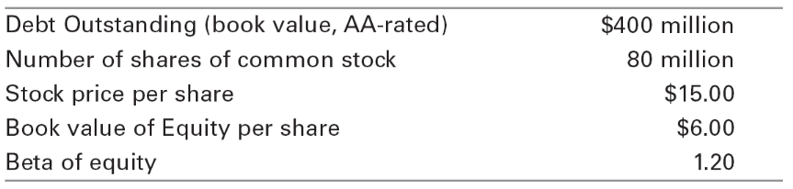
What is your estimate of the project’s beta? What assumptions do you need to make?
Assume debt is risk-free and market value = book value. Assume comparable assets have same risk as project.
Be = 1.20, Bd = 0
E = 15 × 80 = 1200
D = 400
Bu = (1200/1600) × 1.20 + (400/1600) × 0 = 0.90
12-21. In mid-2012, Cisco Systems had a market capitalization of $101 billion. It had A-rated debt of $16 billion as well as cash and short-term investments of $48 billion, and its estimated equity beta at the time was 1.23.
a. What is Cisco’s enterprise value?
b. Assuming Cisco’s debt has a beta of zero, estimate the beta of Cisco’s underlying business enterprise.
a. EV = E + D – C = 101 + 16 – 48 = $69 billion
b. Net Debt = 16 – 48 = –32
Ru = (101/69) × 1.23 + (–32/69) × 0 = 1.80
12-22. Consider the following airline industry data from mid-2009:
Company Name | Market Capitalization ($mm) | Total Enterprise Value ($mm) | Equity Beta | Debt Ratings
Delta Air Lines (DAL) | 4,938.5 | 17,026.5 | 2.04 | BB
Southwest Airlines (LUV) | 4,896.8 | 6,372.8 | 0.966 | A/BBB
JetBlue Airways (JBLU) | 1,245.5 | 3,833.5 | 1.91 | B/CCC
Continental Airlines (CAL) | 1,124.0 | 4,414.0 | 1.99 | B

a. Use the estimates in Table 12.3 to estimate the debt beta for each firm (use an average if multiple ratings are listed).
b. Estimate the asset beta for each firm.
c. What is the average asset beta for the industry, based on these firms?
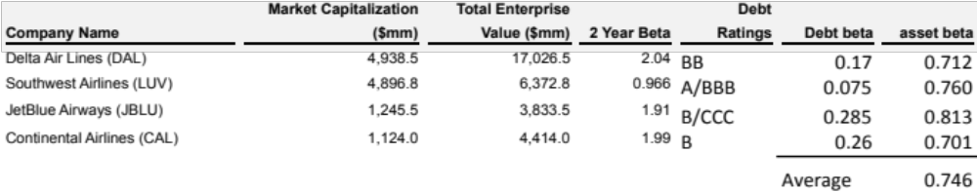
12-23. Weston Enterprises is an all-equity firm with three divisions. The soft drink division has an asset beta of 0.60, expects to generate free cash flow of $50 million this year, and anticipates a 3% perpetual growth rate. The industrial chemicals division has an asset beta of 1.20, expects to generate free cash flow of $70 million this year, and anticipates a 2% perpetual growth rate. Suppose the risk-free rate is 4% and the market risk premium is 5%.
a. Estimate the value of each division.
b. Estimate Weston’s current equity beta and cost of capital. Is this cost of capital useful for valuing Weston’s projects? How is Weston’s equity beta likely to change over time?
a. Soft drink
Ru = 4% + 0.6 × 5% = 7%
V = 50/(7% – 3%) = 1,250
Chemical
Ru = 4% + 1.20 × 5% = 10%
V = 70/(10% – 2%) = 875
Total = 1250 + 875 = $2.125 billion
b. Weston Beta (portfolio)
1250/2125 × 0.6 + 875/2125 × 1.2 = 0.85
Re = 4% + 0.85 × 5% = 8.25%
Not useful! Individual divisions are either less risky or more risky. Over time, Weston’s equity beta will decline towards 0.6 as the soft drink division has a higher growth rate, and so will represent a larger fraction of the firm.
12-24. Harrison Holdings, Inc. (HHI) is publicly traded, with a current share price of $32 per share. HHI has 20 million shares outstanding, as well as $64 million in debt. The founder of HHI, Harry Harrison, made his fortune in the fast food business. He sold off part of his fast-food empire, and purchased a professional hockey team. HHI’s only assets are the hockey team, together with 50% of the outstanding shares of Harry’s Hotdogs restaurant chain. Harry’s Hotdogs (HDG) has a market capitalization of $850 million, and an enterprise value of $1.05 billion. After a little research, you find that the average asset beta of other fast-food restaurant chains is 0.75. You also find that the debt of HHI and HDG is highly rated, and so you decide to estimate the beta of both firms’ debt as zero. Finally, you do a regression analysis on HHI’s historical stock returns in comparison to the S&P 500, and estimate an equity beta of 1.33. Given this information, estimate the beta of HHI’s investment in the hockey team.
HHI Equity = 32 × 20 = $640
HHI debt = $64
HHI asset beta = (640/(640 + 64)) 1.33 + (64/(640+64)) 0 = 1.21
Holdings of Hotdogs = 850/2 = 425
Value of Hockey Team = (640 + 64) – 425 = $279
Hotdog equity beta : (850/1,050) × Be + (200/1,050) × 0 = 0.75
Be = 0.75 × 1,050/850 = 0.93 for hotdog equity
So, if B = hockey team beta,
(425/(425 + 279)) 0.93 + (279/(425 + 279)) × B = 1.21
B = 1.64
Beta of hockey team = 1.64
12-25. Your company operates a steel plant. On average, revenues from the plant are $30 million per year. All of the plants costs are variable costs and are consistently 80% of revenues, including energy costs associated with powering the plant, which represent one quarter of the plant’s costs, or an average of $6 million per year. Suppose the plant has an asset beta of 1.25, the risk-free rate is 4%, and the market risk premium is 5%. The tax rate is 40%, and there are no other costs.
a. Estimate the value of the plant today assuming no growth.
b. Suppose you enter a long-term contract which will supply all of the plant’s energy needs for a fixed cost of $3 million per year (before tax). What is the value of the plant if you take this contract?
c. How would taking the contract in (b) change the plant’s cost of capital? Explain.
a. FCF = (30 – 0.8(30))(1 – 0.40) = 3.6 million
Ru = 4% + 1.25 × 5% = 10.25%
V= 3.6/0.1025 = 35.12 million
b. FCF without energy = (30 – 18)(1 – 0.40) = 7.2
Cost of capital = 10.25%
Energy cost after tax = 3(1 – 0.40) = 1.8
Cost of capital = 4%
V = 7.2/.1025 – 1.8/0.04 = 70.24 – 45 = 25.24 million
c. FCF = 7.2 – 1.8 = 5.4
5.4/25.24 = 21.4%
Risk is increased because now energy costs are fixed. Thus a higher cost of capital is appropriate.
12-26. Unida Systems has 40 million shares outstanding trading for $10 per share. In addition, Unida has $100 million in outstanding debt. Suppose Unida’s equity cost of capital is 15%, its debt cost of capital is 8%, and the corporate tax rate is 40%.
a. What is Unida’s unlevered cost of capital?
b. What is Unida’s after-tax debt cost of capital?
c. What is Unida’s weighted average cost of capital?
a. E = 40 × $10 = $400
D = $100
Ru = 400/500 × 15% + 100/500 × 8% = 13.6%
b. Rd = 8% × (1 – 40%) = 4.8%
c. Rwacc = 400/500 × 15% + 100/500 × 4.8% = 12.96%
12-27. You would like to estimate the weighted average cost of capital for a new airline business. Based on its industry asset beta, you have already estimated an unlevered cost of capital for the firm of 9%. However, the new business will be 25% debt financed, and you anticipate its debt cost of capital will be 6%. If its corporate tax rate is 40%, what is your estimate of its WACC?
Ru = 9% = 75% Re + 25% Rd = 75% Re + 25%(6%)
Re = (9% – 25%(6%))/75% = 10%
Rwacc = 75%(10%) – 25%(6%)(1 – 40%) = 8.4%

